EXIT METHOD
Use Exit to terminate the program and stop all threads.
When your program starts, a thread is spawned to run the program. To terminate the thread, you have to invoke the exit method.

IDENTIFIER
An identifier is a sequence of characters that consist of letters, digits, underscores (_), and dollar signs ($).
An identifier must start with a letter, an underscore (_), or a dollar sign ($). It cannot start with a digit.
An identifier cannot be a reserved word. (See Appendix A, “Java Keywords,” for a list of reserved words).
An identifier cannot be true, false, or null.
An identifier can be of any length.

byte 8 bits
short 16 bits
int 32 bits
long 64 bits
float 32 bits
double 64 bits
❖ Scientific notation:
➢ 5 E 2 means 5 * 102

Operator Example Equivalent
+= i+=8 i = i+8
-= f-=8.0 f = f-8.0
*= i*=8 i = i*8
/= i/=8 i = i/8
%= i%=8 i = i%8

The precedence and associativity rules specify the order of the operators, but do not specify the order in which the operands of a binary operator are evaluated. Operands are evaluated from left to right in Java.
The left-hand operand of a binary operator is evaluated before any part of the right-hand operand is evaluated.

Since Java 2, only the following types of expressions can be statements:
variable op= expression; // Where op is +, -, *, /, or %
++variable;
variable++;
--variable;
variable--;

Operator Name
< less than
<= less than or equal to
> greater than
>= greater than or equal to
== equal to
!= not equal to

Operator Name
! not
&& and
|| or
^ exclusive or

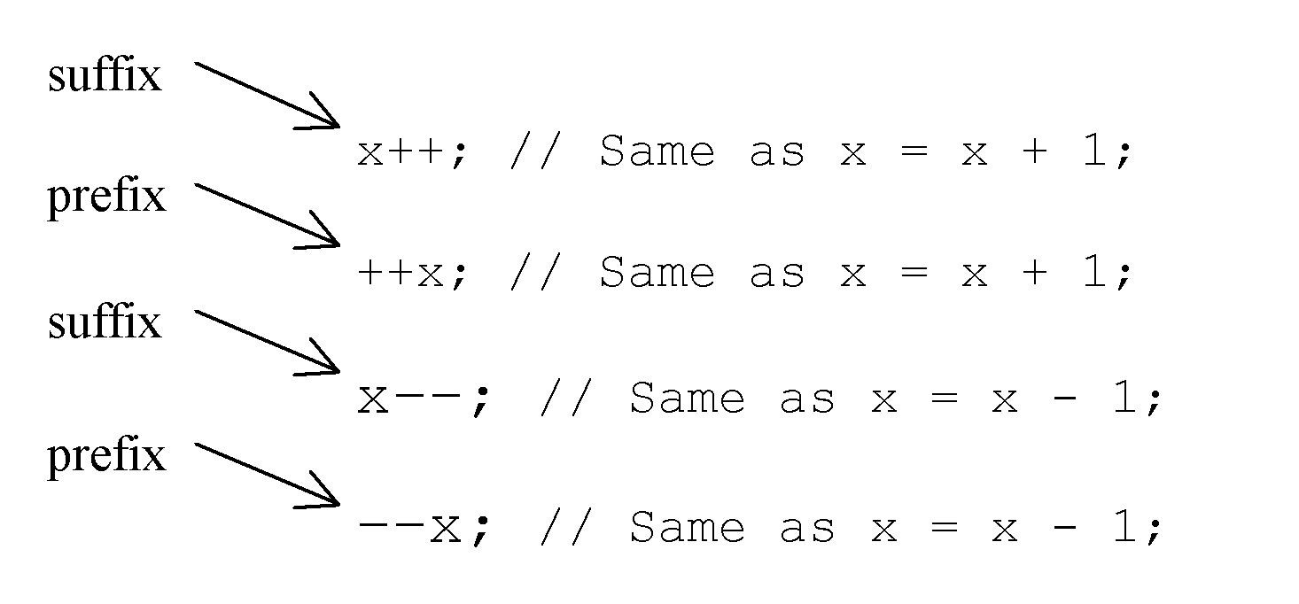
Operator Precedence
- var++, var--
- +, - (Unary plus and minus), ++var,--var
- (type) Casting
- ! (Not)
- *, /, % (Multiplication, division, and modulus)
- +, - (Binary addition and subtraction)
- <, <=, >, >= (Comparison)
- ==, !=; (Equality)
- & (Unconditional AND)
- ^ (Exclusive OR)
- | (Unconditional OR)
- && (Conditional AND) Short-circuit AND
- || (Conditional OR) Short-circuit OR
- =, +=, -=, *=, /=, %= (Assignment operator)

Compiling and Executing

• To compile the program, execute the compiler, javac, specifying the name of the source file on the command line
• The javac compiler creates a file called Example.class that contains the bytecode version of the program.
• To run the program, you must use the Java application launcher called java and pass the class name, Example, as a command-line Argument

Bytecode

• The Java bytecode is the intermediate representation of your program that contains instructions the Java Virtual Machine (JVM) will execute.
• This intermediate code is platform independent (you can take this bytecode from a machine running windows and use it in any other machine running Linux or MacOS etc).
• Also this bytecode is only understandable by the JVM and not the user or even the hardware /OS layer.

Run Time

• Run Time phase starts when the bytecode is loaded into the JVM by the class loader (another inbuilt program inside the JVM).
• Now the bytecode verifier (an inbuilt program inside the JVM) checks the bytecode for its integrity and if no issues are found, passes it to the interpreter.
• The interpreter inside the JVM converts each line of the bytecode into executable machine code and passes it to the CPU to execute.

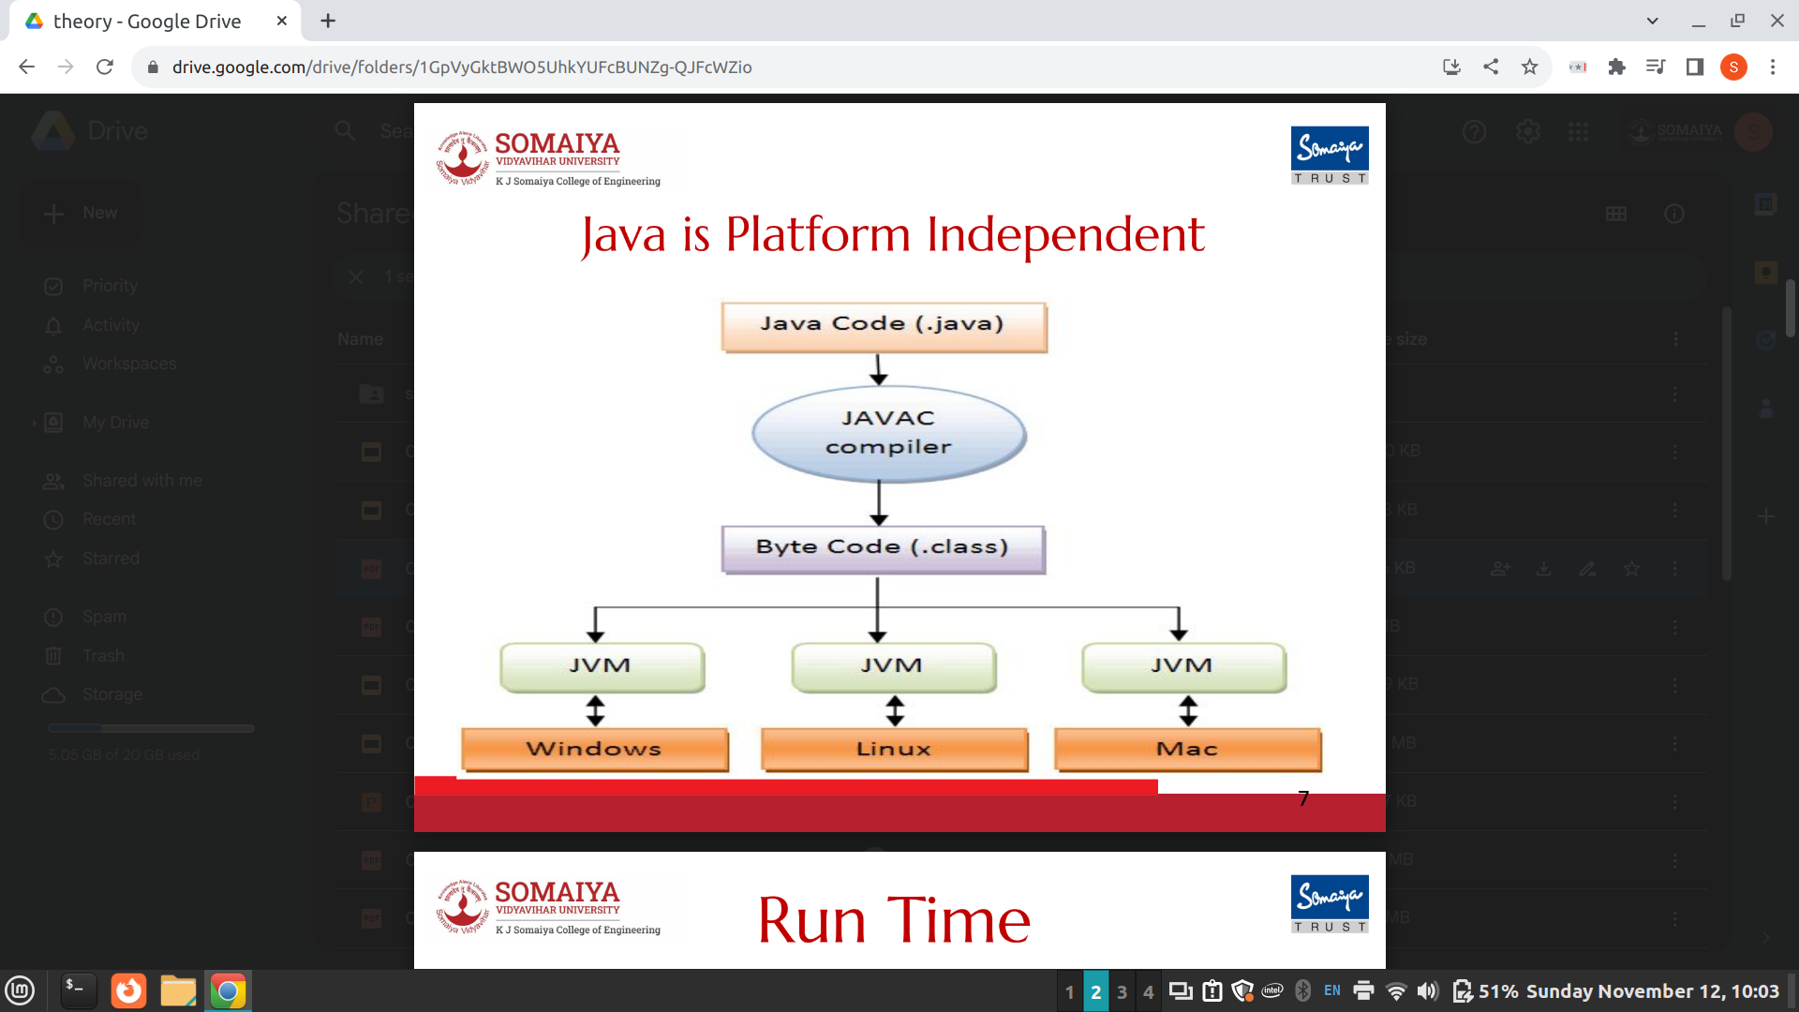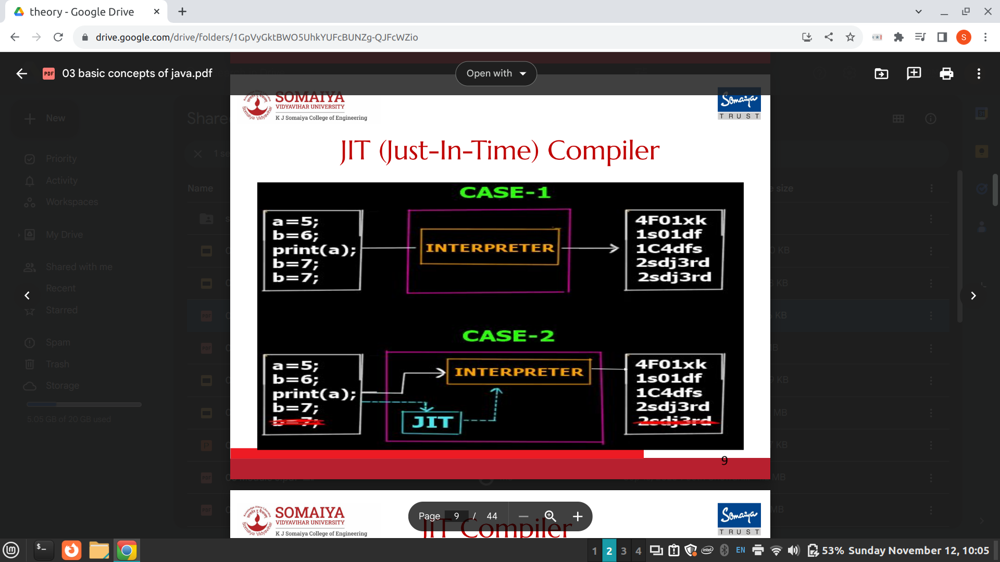

JIT Compiler

• The last 2 lines (both b = 7 ) are the same (redundant).
• Clearly the second line does not have any effect on the actual output.
• Since the interpreter works line by line it still creates 5 lines of machine code for 5 lines of the bytecode in Case 1.
• This is inefficient.

JIT Compiler

• In case 2 we have the JIT compiler.
• Now before the bytecode is passed onto the interpreter for conversion to machine code, the JIT compiler scans the full code to see if it can be optimized.
• As it finds the last line is redundant it removes it from the bytecode and passes only 4 lines to the interpreter thus making it more efficient and faster as the interpreter now has 1 line less to interpret.
• JIT compiler optimizations can include inlining functions, constant folding, dead code elimination, and more. The goal is to produce highly efficient machine code tailored for the specific execution environment.

Class Definition

• The next line of code in the program is : class Example {
• This line uses the keyword class to declare that a new class is being defined.
• Example is an identifier that is the name of the class.
• The entire class definition, including all of its members, will be between the opening curly brace ({) and the closing curly brace (}).

main()

• The next line of code is shown here: public static void main(String[] args) {
• This line begins the main( ) method.
• This is the line at which the program will begin executing.
• As a general rule, a Java program begins execution by calling main( ).
• main( ) is simply a starting place for your program.
• A complex program will have dozens of classes, only one of which will need to have a main( ) method to get things started.

Printing output on screen

• The next line of code is shown here. Notice that it occurs inside main( ). System.out.println("This is a simple Java program.");
• This line outputs the string "This is a simple Java program." followed by a new line on the screen.
• This is accomplished by the built-in println( ) method.
• The line begins with System.out.
• System is a predefined class that provides access to the system, and out is the output stream that is connected to the console (screen).

Signature of main()

• The public keyword is an access modifier.
• main( ) must be declared as public, since it must be called by code outside of its class when the program is started. (JVM)
• The keyword static allows main( ) to be called without having to instantiate a particular instance of the class.
• This is necessary since main( ) is called by the JVM before any objects are made.
• main( ) has only one parameter String[ ] args
• String[ ] args declares a parameter named args, which is an array of instances / objects of the class String.
• Objects of type String store character strings.
• In this case, args receives any command-line arguments present when the program is executed.
System.out.println("You entered: " + num);
• In this statement, the plus sign causes the value of num to be appended to the string that precedes it, and then the resulting string is output.
• Actually, num is first converted from an integer into its string equivalent and then concatenated with the string that precedes it.

Input

In Java, you can take input from the user using the Scanner class, which is part of the java.util package.
❖ Step 1 : Import the Scanner class:
➢ import java.util.Scanner;
❖ Step 2 : Create a Scanner object:
➢ Scanner scanner = new Scanner(System.in);
➢ System.in represents the standard input stream, which is typically the keyboard.

❖ Step 3 : Prompt the user for input:
➢ Although not strictly necessary, it's a good practice to provide a prompt to the user so they know what kind of input is expected.
For example:
➢ System.out.print("Enter your name: ");

❖ Step 4 : Read input:
➢ The Scanner class provides various methods to read different data types.
➢ String nextLine()
■ Reads and returns the next line of input as a string. (Specifically, it reads and returns all the remaining characters on the line as a character string, and then moves to the next line.)

➢ String next()
■ Reads and returns the next input token as a character string.
➢ double nextDouble()
■ Reads and returns a double value. If the next token cannot be translated to a double, throws InputMismatchException.

➢ int nextInt()
■ Reads and returns an int value. If the next token cannot be translated to an int, throws InputMismatchException.

➢ In general, type nextType()
➢ For example:
■ String name = scanner.nextLine();
➢ Also refer the source code ConsoleIO_Scanner.java

Naming Conventions

• Class names should be nouns, in mixed case, with the first letter of each internal word capitalized.

• Try to keep your class names simple and descriptive.
• Use whole words-avoid acronyms and abbreviations (unless the abbreviation is much more widely used than the long form, such as URL or HTML).

• Method names should contain a verb, as they are used to make an object take action.

• They should be mixed case, beginning with a lowercase letter, and the first letter of each subsequent word should be capitalized.

• Adjectives and nouns may be included in method names:
o public void locate() {...} // verb
o public String getBalance() {...} // verb and noun

• Instance and static variable names should be nouns and should follow the same capitalization convention as method names:
o private String wayPoint;

• Parameter and local variable names should be descriptive lowercase single words, acronyms, or abbreviations. If multiple words are necessary, they should follow the same capitalization convention as method names:
public void printHotSpots(ArrayList spotList) {
int counter = 0;
for (String hotSpot : spotList) {
System.out.println("Hot Spot #"
+ ++counter + ": " + hotSpot); }}

• Temporary variable names may be single letters such as i, j, k, m, and n for integers and c, d, and e for characters.

• Constant names should be all uppercase letters, and multiple words should be separated by underscores:
public static final int MAX_DEPTH = 200;

Creating Objects

• Creating objects of a class is a two-step process.
• First, you must declare a variable of the class type.
o This variable does not define an object. Instead, it is simply a variable that can refer to (contain the address of) an object.
• Second, you must acquire an actual, physical copy of the object and assign it to that variable.
o You can do this using the new operator.
o The new operator dynamically allocates (that is, allocates at run time)
memory for an object and returns a reference to it.
o This reference is, essentially, the address in memory of the object allocated by new.
• This reference is then stored in the variable.
• Thus, in Java, all the objects must be dynamically allocated.

❖ In the preceding sample programs, a line similar to the following is used to declare an object of type Box:
➢ Box mybox = new Box();
❖ It can be rewritten like this to show each step more clearly:
➢ Box mybox; // declare reference to object
➢ mybox = new Box(); // allocate a Box object
❖ The first line declares mybox as a reference to an object of type Box.
➢ At this point, mybox does not yet refer to an actual object.
❖ The next line allocates an object and assigns its memory address to mybox.
❖ After the second line executes, you can use mybox as if it were a Box object.

❖ Each time you create an instance of a class, you are creating an object that contains its own copy of each instance variable defined by the class.
❖ Thus, every Box object will contain its own copies of the instance variables width, height, and depth.
❖ To access these variables, you will use the dot (.) operator.
❖ The dot operator links the name of the object with the name of an instance variable.
❖ mybox1.width = 10;
❖ This statement tells the compiler to assign the value of 10 to the copy of width that is contained within the mybox1 object.
❖ In general, you use the dot operator to access both the instance variables and the methods within an object.

Destructor

• Constructors and destructors create and destroy objects of a class, respectively.
• Destructors reverse the construction process.
• They must deallocate memory when appropriate and perform other cleanup activities like closing open file handles.
• There are no destructors in Java.
• Instead, Java uses a garbage collector to automatically deallocate memory when an object is no longer needed.
• The garbage collector is a program that runs in the background and tracks
which objects are still being used and which objects can be deleted.
• In Java, there is no need for destructors because the garbage collector will automatically deallocate memory when an object is no longer needed.

Garbage Collection

• When no references to an object exist, that object is assumed to be no longer needed, and the memory occupied by the object can be reclaimed.
• There is no need to explicitly destroy objects.
• Garbage collection only occurs sporadically (if at all) during the execution of your program. It will not occur simply because one or more objects exist that are no longer used.
• Furthermore, different Java run-time implementations will take varying approaches to garbage collection.
TIP: If you know that an object is no longer needed, you can explicitly assign null to a reference variable for the object. The JVM will automatically collect the space if the object is not referenced by any variable.

Garbage Collection : System.gc()
public static void gc()
Request to run the garbage collector.
Invoking the 'gc' method in Java prompts the Virtual Machine to free up memory by recycling unused objects for future use.
When control returns from the method call, one can say that the Java
Virtual Machine has made its “best effort” to reclaim space from all discarded objects.

Overloading Vs Overriding

Overriding: Declaring a method in a subclass with the same signature as a method in its superclass.
Overloading: Declaring a method with the same name, different parameters.

Binding

• Definition: Binding = Associating a method definition with its invocation.
• In early binding, a method’s definition is associated with its invocation when the code is compiled.
• In late binding, a method’s definition is associated with the method’s invocation at execution time. In late binding the method invoked is determined by the type of object to which the variable refers, NOT by the type of the reference variable.

Java uses late binding for all methods except for:
• final methods (If a method of a class is declared final, it cannot be overridden with a new definition in a derived class.)
• private methods
• static methods.

Method | Description
public String next() | it returns the next token from the scanner.
public String nextLine() | it moves the scanner position to the next line and returns the value as a string.
public byte nextByte() | it scans the next token as a byte.
public short nextShort() | it scans the next token as a short value.
public int nextInt() | it scans the next token as an int value.
public long nextLong() | it scans the next token as a long value.
public float nextFloat() | it scans the next token as a float value.
public double nextDouble() | it scans the next token as a double value.

Static

- Static variables are shared by all the instances of the class.
- Static methods are not tied to a specific object. Because of this, a static method cannot access instance members of the class
- Static constants are final variables shared by all the instances of the class.
- A non-static (or instance) variable is tied to a specific instance
- Static variables store values for the variables in a common memory location. Because of this common location, if one object changes the value of a static variable, all objects of the same class are affected.
- Java supports static methods as well as static variables. Static methods can be called without creating an instance of the class.
- To declare static variables, constants, and methods, use the static modifier. For example, the constant PI in the Math class is defined as
final static double PI=3.14159265358979323846

Static and Instance Methods

An instance method can invoke an instance or static method and access an instance or static data field. A static method can invoke a static method and access a static data field. However, a static method cannot invoke an instance method or access an instance data field, since static methods and static data fields don’t belong to a particular object.
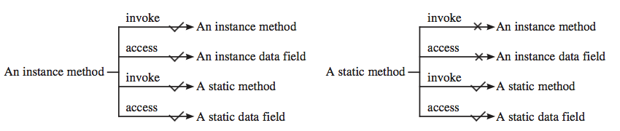
- You can use the public visibility modifier for classes, methods, and data fields to denote that they can be accessed from any other classes.
- If no visibility modifier is used, then by default the classes, methods, and data fields are accessible by any class in the same package. This is known as package-private or package-access.
- Packages can be used to organize classes. To do so, you need to add the following line as the first statement in the program:
package packageName;
- If a class is defined without the package statement, it is said to be placed in the default package.

Visibility Modifiers
- The private modifier applies only to the members of a class. The public modifier can apply to a class or members of a class. Using the modifiers public and private on local variables would cause a compile error.
- In most cases, the constructor should be public. However, if you want to prohibit the user from creating an instance of a class, use a private constructor. For example, there is no reason to create an instance from the Math class, because all of its data fields and methods are static. To prevent the user from creating objects from the Math class, the constructor in java.lang.Math is defined as private.

Static variable
- When a variable is declared with the keyword “static”, its called a “class variable”.
- All instances share the same copy of the variable. A class variable can be accessed directly with the class, without the need to create a instance. It makes your program memory efficient.

Static method
- A static method belongs to the class rather than object of a class.
- A static method can be invoked without the need for creating an instance of a class.
- static method can access static data member and can change the value of it.
- There are two main restrictions for the static method. They are:
      - The static method can not use non static data member or call non-static method directly.
      - this and super cannot be used in static context

Static block
- Is used to initialize the static data member.
- It is executed before main method at the time of classloading.
- So this is one of the way to execute a program without main() method

class A2{
static{System.out.println("static block is invoked");}
public static void main(String args[]){
System.out.println("Hello main");
}
}
OUTPUT: static block is invoked
Hello main

Switch statements
- The switch-expression must yield a value of char, byte, short, or int type and must always be enclosed in parentheses.

- The value1, ..., and valueN must have the same data type as the value of the switch-expression.

- The resulting statements in the case statement are executed when the value in the case statement matches the value of the switch-expression. (The case statements are executed in sequential order.)
- The keyword break is optional, but it should be used at the end of each case in order to terminate the remainder of the switch statement. If the break statement is not present, the next case statement will be executed.

- In Labelled Break Statement, we give a label/name to a loop.
- When this break statement is encountered with the label/name of the loop, it skips the execution any statement after it and takes the control right out of this labelled loop.
- And, the control goes to the first statement right after the loop.
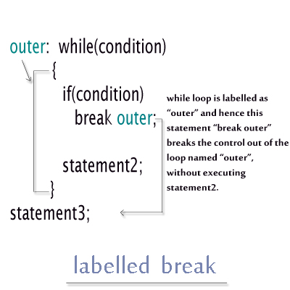
- Referencing the object’s data is done using the dot operator or object member access operator:
objectRefVar.data
e.g., myCircle.radius

- Invoking the object’s method:
objectRefVar.methodName(arguments)
e.g., myCircle.getArea()

The default value of a data field is null for a reference type, 0 for a numeric type, false for a boolean type, and '\u0000' for a char type. However, Java assigns no default value to a local variable inside a method.

int capacity() This method returns the current capacity of this vector.
void clear() This method removes all of the elements from this vector.
clone clone() This method returns a clone of this vector.
boolean contains(Object o) This method returns true if this vector contains the specified element.
boolean isEmpty()This method tests if this vector has no components.
void setSize(int newSize)This method sets the size of this vector.
int size()This method returns the number of components in this vector.

Access Specifiers in Java

- Public: A class, method, constructor, interface etc can be accessed from any other class. Therefore fields, methods, blocks declared inside a public class can be accessed from any class belonging to the Java Universe. However if the public class we are trying to access is in a different package, then the public class still need to be imported. Because of class inheritance, all public methods and variables of a class are inherited by its subclasses.
- Protected: Variables, methods and constructors can be accessed only by the subclasses in other package or any class within the package of the protected members' class. The protected access modifier cannot be applied to class and interfaces. Methods, fields can be declared protected, however methods and fields in a interface cannot be declared protected. Protected access gives the subclass a chance to use the helper method or variable, while preventing a nonrelated class from trying to use it.
- Private: Methods, Variables and Constructors can only be accessed within the declared class itself. Private access modifier is the most restrictive access level. Class and interfaces cannot be private. Variables that are declared private can be accessed outside the class if public getter methods are present in the class. Using the private modifier is the main way that an object encapsulates itself and hide data from the outside world.
- Default: Default access modifier means we do not explicitly declare an access modifier for a class, field, method, etc. A variable or method declared without any access control modifier is available to any other class in the same package. The fields in an interface are implicitly public static final and the methods in an interface are by default public.

Access Specifiers
• public means accessibility for all
• private means accessibility from within the class only
• default (blank) access specifiers are accessible only from within the
package
• protected means accessibility outside the packages but only to subclasses

Immutable Objects

- Normally, you create an object and allow its contents to be changed later. However, occasionally it is desirable to create an object whose contents cannot be changed once the object has been created. We call such an object as immutable object and its class as immutable class.

- If a class is immutable, then all its data fields must be private and it cannot contain public setter methods for any data fields. A class with all private data fields and no mutators is not necessarily immutable.

this Keyword
- The this keyword is the name of a reference that refers to an object itself. One common use of the this keyword is reference a class’s hidden data fields.
- Another common use of the this keyword to enable a constructor to invoke another constructor of the same class.

Collection Framework

• Provides an architecture to store and manipulate a group of objects
• Achieve all the operations that you perform on a data such as searching, sorting, insertion, manipulation, and deletion
• Java Collection means a single unit of objects
• Java Collection framework provides many interfaces (Set, List,
Queue, Deque) and classes (ArrayList, Vector, LinkedList, PriorityQueue, HashSet, LinkedHashSet, TreeSet)

Iterator interface

• Iterator interface provides the facility of iterating the elements in forward
direction only
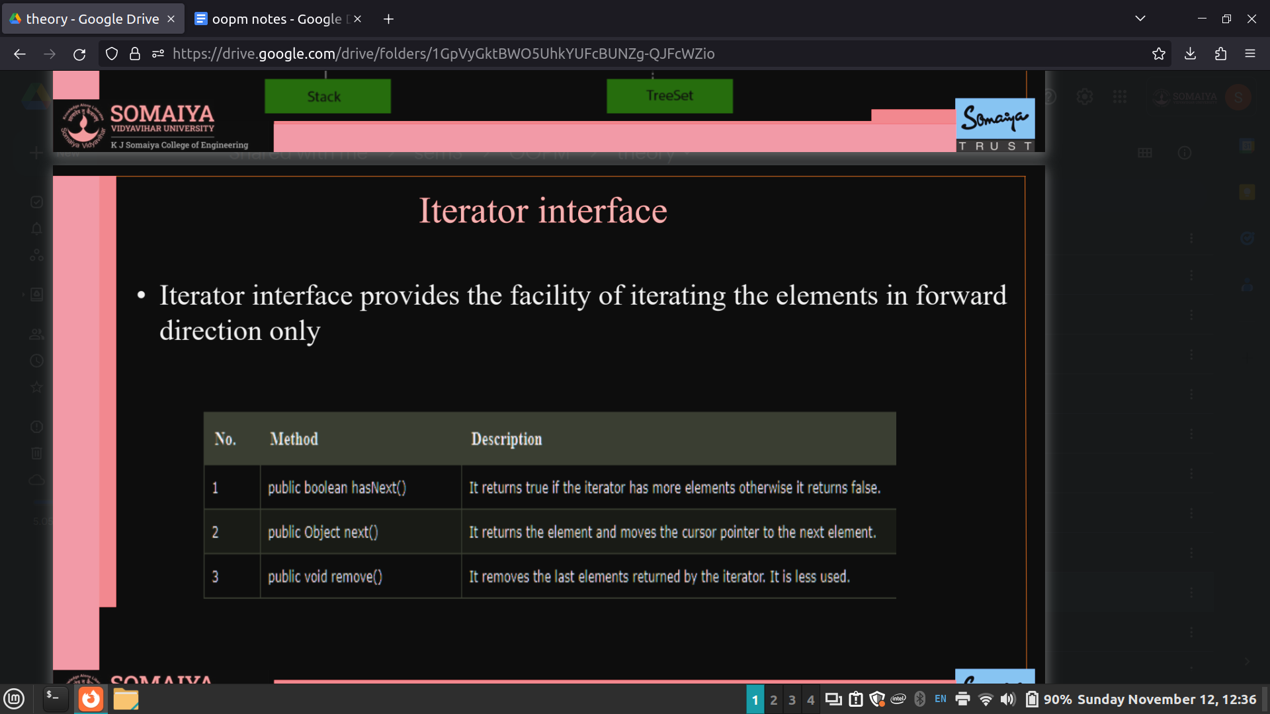

Collection Interface

• Interface which is implemented by all the classes in the collection framework
• It declares the methods that every collection will have
• Collection interface builds the foundation on which the collection framework depends
• Some of the methods of Collection interface are
o Boolean add ( Object obj)
o Boolean addAll ( Collection c)
o void clear(), etc.
which are implemented by all the subclasses of Collection interface

List Interface

• List interface is the child interface of Collection interface
• It inhibits a list type data structure in which we can store the ordered collection of objects
• It can have duplicate values
• List interface is implemented by the classes ArrayList, LinkedList, Vector, and Stack.
• To instantiate the List interface, we must use :
List <data-type> list1= new ArrayList();
List <data-type> list2 = new LinkedList();
List <data-type> list3 = new Vector();
List <data-type> list4 = new Stack();

ArrayList

• Java ArrayList class uses a dynamic array for storing the elements( there is no size
limit)
• We can add or remove elements anytime, much more flexible than the traditional array
• It is found in the java.util package
• The ArrayList in Java can have the duplicate elements also
• It implements the List interface so we can use all the methods of List interface here.
• The ArrayList maintains the insertion order internally

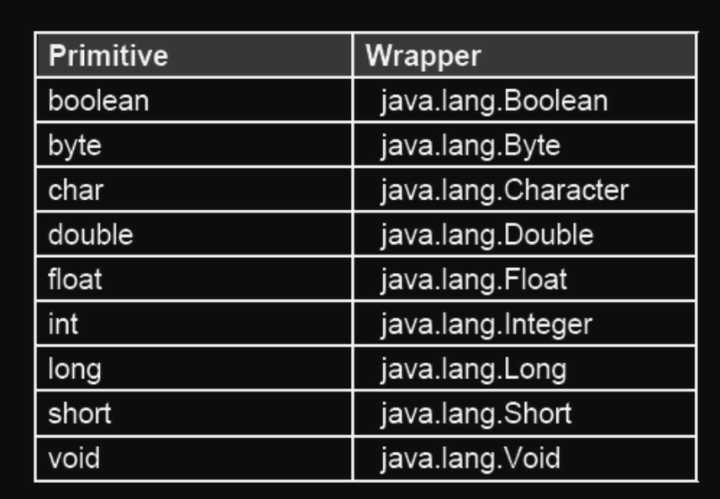

Java Wrapper Classes

• For each primitive type, there is a corresponding wrapper class designed
• Are wrapper around primitive data types
• Allow for situations where primitives cannot be used but their corresponding objects are required
• Normally Used to convert a numeric value to a String or vice-versa
• Just like String, Wrapper objects are also immutable
• All the wrapper classes except Character and Float have two constructors—one that takes the primitive value and another that takes the String representation of the value
• Character has one constructor and float has three
• They convert primitive data types into objects. Objects are needed if we wish to modify the arguments passed into a method (because primitive types are passed by value).
• The classes in java.util package handles only objects and hence wrapper classes help in this case also.
• Data structures in the Collection framework, such as ArrayList and Vector, store only objects (reference types) and not primitive types.
• An object is needed to support synchronization in multithreading

String Class

• Are basically immutable objects in Java
• Immutable means once created the, strings cannot be changed
• Whenever we create strings, it is this class that is instantiated
• In Java strings can be instantiated in two ways:
o String x= “String Literal Object”;
o String y=new String (“String object is created here”);

String Manipulation

• Strings in Java are immutable (read only) in nature, Once defined cannot
be changed. • Let us take an example:
o String x = “Hello”; // ok
o String x = x +”World”; // ok, but how?
• the ‘+’ operator concatenates If at least one of the operand is a string. • The second statement gets converted to the following statement automatically
o String x=new StringBuffer(). append(x). append(“World”). toString();

Java String class methods
Method | Description
char charAt(int index) | It returns char value for the particular index
int length() | It returns string length
boolean isEmpty() | It checks if the string is empty.
int indexOf(int ch) | It returns the specified char value index.
String toLowerCase() | It returns a string in lowercase.
String toUpperCase() | It returns a string in uppercase.
StringBuffer Class
• StringBuffer class is used for representing changing strings
• StringBuffer offers more performance enhancement whenever we change Strings, because it is this class that is actually used behind the curtain
• Just like any other buffer, StringBuffer also has a capacity and if the capacity is exceeded, then it is automatically made larger
• The initial capacity of StringBuffer can be known by using a method capacity()
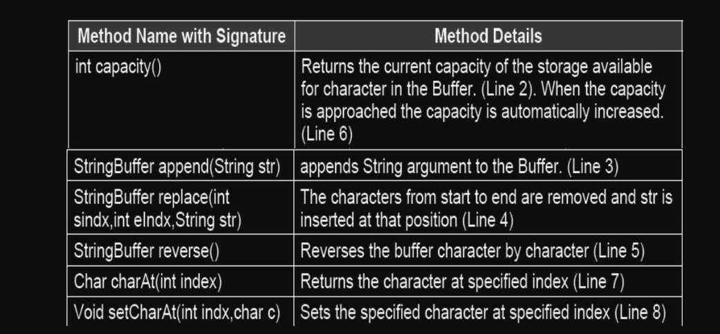

StringBuilder Class
• A substitute of StringBuffer class.
• This class is faster than StringBuffer class, as it is not synchronized
• append(), insert(), delete(), deleteCharAt(), replace(), and reverse() return StringBuilder objects rather than StringBuffer objects
• The line creates a StringBuilder object
o StringBuilder s=new StringBuilder();
o construct a StringBuilder object with an initial capacity of 16 characters. Similar to that
of StringBuffer

